Cron Job

Step 1: Cpanel
Login to your cpanel, the url is most of the time http://yourdomain.com/cpanel

Step 2: Getting your root directory
Look on the left of your cpanel for the home directory. Memorize the url or copy it.
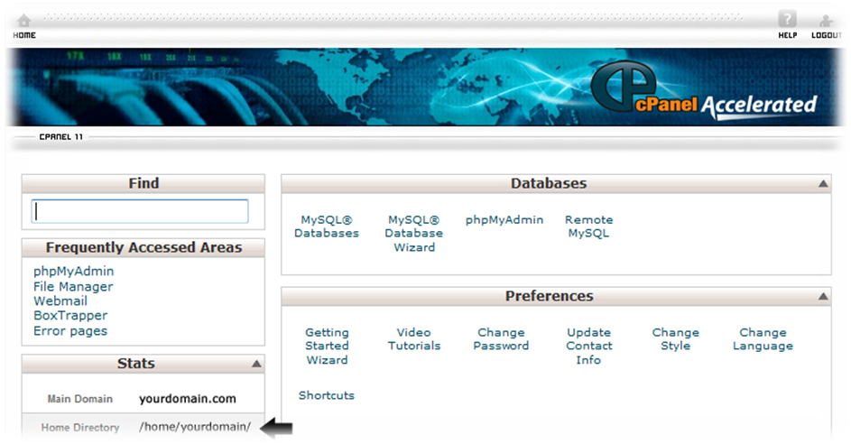

Step 3: Setting up the cron job
Go to cron jobs located under advanced. Than click standard(for simple setup).
At this line “Please enter an email address where the cron output will be sent:” set an email you want, so you can get cron reports delivered.
At this line “Command to run:” put up the command in their, it should look like this php <home directory>/public_html/cron.php (in our example: php /home/yourdomain/public_html/cron.php)
Change Minute(s) and Hour(s) to your refresh time. Don’t touch the other stuff, we only want to refresh jobs ones a day.
